**Ideation Phase**

**Define the Problem Statements**

|  |  |
| --- | --- |
| Date | 26 June 2025 |
| Team ID | LTVIP2025TMID50734 |
| Project Name | Visualizing Housing Market Trends: An Analysis of Sale Prices and Features using Tableau |
| Maximum Marks | 2 Marks |

**Customer Problem Statement Template:**

Create a problem statement to understand your customer's point of view. The Customer Problem Statement template helps you focus on what matters to create experiences people will love.

A well-articulated customer problem statement allows you and your team to find the ideal solution for the challenges your customers face. Throughout the process, you’ll also be able to empathize with your customers, which helps you better understand how they perceive your product or service.

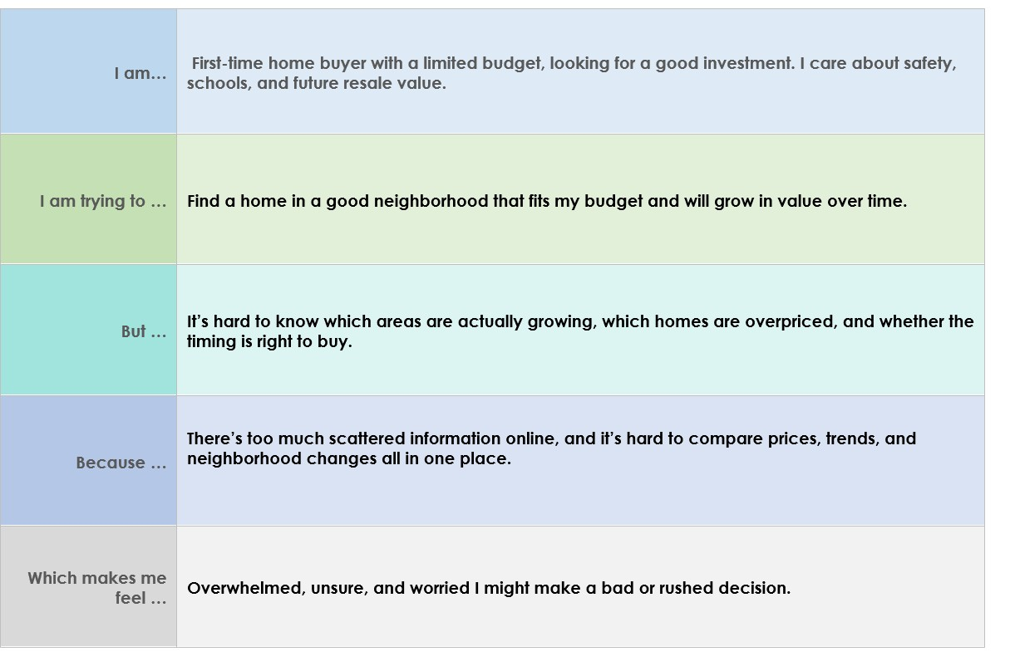

Reference: <https://miro.com/templates/customer-problem-statement/>

**Example:**

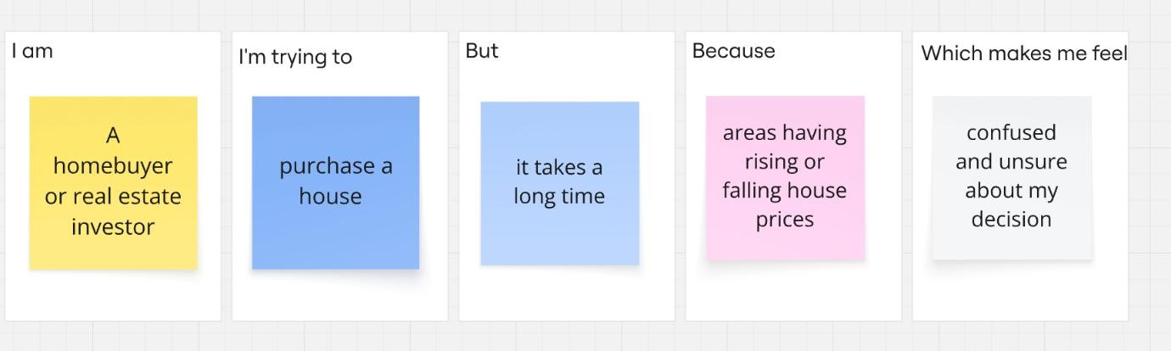

|  |  |  |  |  |  |
| --- | --- | --- | --- | --- | --- |
| **Problem**  **Statement (PS)** | **I am**  **(Customer)** | **I’m trying to** | **But** | **Because** | **Which makes me**  **feel** |
| PS-1 | homebuyer | Buy a house | Selecting  best house  is  challenging | House prices are rising or falling | Confused and Unsure |
| PS-2 | Real estate investor | Identify best neighbourhood | Identifying improving areas is difficult | Don’t know a clear way to compare areas | Worried and stressed |